Question | Artwork 1: The Fifth Vision of Hildegard of Bingen | Artwork 2: Amy Sherald’s Portrait of Michelle Obama | Video: Unboxing Video
Subject Matter | Religious Visions | Portrait of an important person | Entertainment
Medium | Oil on paper | Oil on linen | YouTube Video
Elements & Principles of Design | Bright colors on faces and focal points to make them stand out. Very little empty space. Not much variation in light, mostly darker. | Bright colors on the subject against a plain background so the subject stands out. A lot of empty space and a lot of light. | Fun colors that match
Year and Place | Unknown | 2018; Washington D.C. | 2025
Social, Political, or Spiritual Ideas | Spiritual ideas, visions | Social ideas of women not being least in class and having individuality | Social ideas; charity
Moral Values Represented | Faith | Equality | Charity, giving
Image / Link | 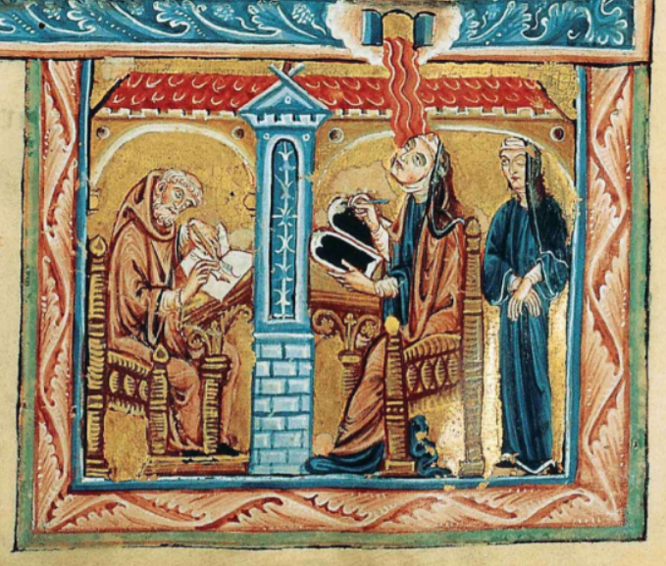 | 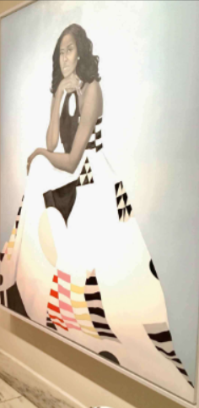 | https://www.youtube.com/watch?v=Vm1GSDEcsN0

